The Story of the Business of Sarah Knows Kids and How Sarah Helen got to do what she does… and Whatever a “Parent Coach”, Parent Supervisor does: The story is ever changing come back for additions and deletions as you please:

WARNING THESE TID BITS about Sarah and how she knows so much about kids ARE NOT FOR THE FAINT OF HEART-strong language and story content.

Once upon a time—some dude ate a bat across the world and I was told I shouldn’t come back to work at her stable 16 years in the making lovely career, it was not essential for me to be a career travel nanny at this time.
The narrator added
“Sarah—you went from being a babysitter to someone subpoenaed to testify in child/domestic related case because of covid ???” Oh, sweet baby brain. If it was only that simple.

When I was 14 I told my mom the job I wanted when I grew up. It wasn’t a teacher… it was not a counselor… it was not a probation officer even though my fascination with prisons kept my eye wanting to work with “ bad guys” always grabbed my attention.
It was some job that is between schools, homes, and –dateline. I also like to color and play games though. So now I do this job post- world ending and restarting.
Now I am here and I know--- A lot about kids, human development, family system, relational psychology, American penal system and control and manipulation through emotional dysregulation and button pushing. +kids tend to like me. I am previously known as: The baby whisper, “oh my god you are here!! Thank You!”, best friend, worst enemy, and “who do you think you are, you are so unprofessional”. My favorite: complicated and over the top.

Hi- I am Sarah.
My undergrad is in Human Development and Family Studies with a concentration in graduate adolescent research. My master’s works is in Child Development from an international university in the UK (excuse to assimilate into European/British culture and childminding for 3ish years on and off; yes please!). My continuing education of certificates and licensure adventures varies depending on my current muse- ranging from psychology of happiness, creative experiences for children, child-lead parenting, love and logic, conscious discipline, safe sleeping methods, child-life specialist, cooperative co-parent communication with high-conflict divorces, to domestic abuse and victims of sexual assault and human trafficking. Most importantly: the experience. I mentored under the best of the best. I have done it seen it and let the industry change me on a deep emotional level- you think your child custody battle is the worst of the worst—I think not. I hold worse stories than yours, stop complaining and sort yourself out.
There is not enough space on the a resume to explain the life experience it takes to be in the shoes I am in currently.
I am the parent coach without a living child, but I label myself a mother.
I am the previous middle school sex ed teacher.
I am the cool Aunt with trinkets from travels from far away places.
I am—intricate and difficult.
My role is to keep children safe and advocate for the observation of their physical safety in the present tense. I stay out of the chaos of the past- I avoid the hopes of the future. I emotionally regulate the environment: today. I play with kids and making positive neuron connections and memories today. I don’t pick sides of the past: I babysit parent’s who have lost custody of their children and I hold hands of those who are at their lowest and meet them where they are at. . .today… I also as a prize of the career. I deal with child abusers, unfit parents and psychopaths…
Those individuals procreate children also.
I am a stepping stone in the family court system. I work hard, and took a lot of shit to get here. I am the least professional-- professional you will meet.

What is an experience with sarahknowskids like?
Parental Supervision—Sarah has strict scanning intake processes.
She is going to tell you: Contact Red Tent Family Center-not today Satan.

ALL CURRENT CLIENTS MUST BE GRADUATED FROM PROFESSIONAL SUPERVISION BEFORE I WILL ACCEPT THEM! (community and family supervision exempt from this rule) WITH A EXIT/TRANSFER INTERVIEW FROM YOUR PREVIOUS SUPERVISOR TO ME.

I am not and will not be your first contact and professional with your fresh new court orders---That’s not my niche- Contact a supervision center, see you when you finish that step. This is my boundary! I will not take families in active chaos and actively upping the emotion in the room.
My services are for those who took it too far in a fit of anger and are tired of your own noise and ready to get back to “normal family life”. I am here for the families that have thrown in the anger towel and ready to support their children as co-parents (not cooperative co-parents ) respectfully/honestly/minimalistic-ly/age-appropriately.
And with manners and dignity for both households/ or taboo situations you’ve buried yourself in.

I move the story forward and my goal is to fire clients ASAP and never once go to trial and testify on a parents behalf. I speak for the innocence of the children’s unspoken words. I strive to protect the children of high conflict divorces from as much inner childhood trauma of the future that is possible for one random chick named Sarah to hold.
I coach parents- any one who has done the dirty and now there is living flesh on this floating rock we all are on right now… I coach you.
What is a coach- (a court ordered parent coach exactly) it is an unlicensed, unregistered professional in a position of power that role models appropriate behavior for people who are sooooooo high up on their high parental horse, with their head so far up in a deep dark place—A parent coach kicks them where it counts to get them back into reality.
And putting the child’s best interest first…
While sometimes arguing/consulting with other professionals in the game of family law.

I---just choose to run my own ethics board-DORA…does not have a license for people who---people watch—and hold really sick and twisted stories. I hold the unlovable/discarded/deadbeat parents and give them the chance to rebuild their own dignity. Hold people accountable for their own stories- and inner childhood bullshit making them unsafe and unfit parents according to the court of law.

Hey parents Ill give you the tip: put your ego down. That’s it, I coach you to put your ego down-Ill exhaust your emotions and push you by being obnoxious/invasive/ and down right unprofessional (that’s the personalized part of the parent coaching piece)
I will mirror you- so you see how sick and twisted you’ve become—and you will change yourself. Or you will get off my caseload.

So that is what I do for a living.
One- (expensive/ I didn’t say my safety in this kind of job did not come with a pricetag) coaching session at a time.
Hello I am Sarah, I know kids.
Why November 2020 did this business start.

A mom-with the same vague name as me needed a hand with her children’s wellbeing and future.
I don’t know the exact, exact details of what happened a day almost 3 years prior to this letter being written-but I know is was gross, and uncalled for from both parents big egos and heightened emotional states.
Thanksgiving 2020-Love Won
Valentines Day 2021-Love still Wins
Love does not die. It strengthens. It transforms throughout the love story
This is the family whose story pushed me into Sarah Knows Kids.
There are too many stories this one: meet my first supervision client.
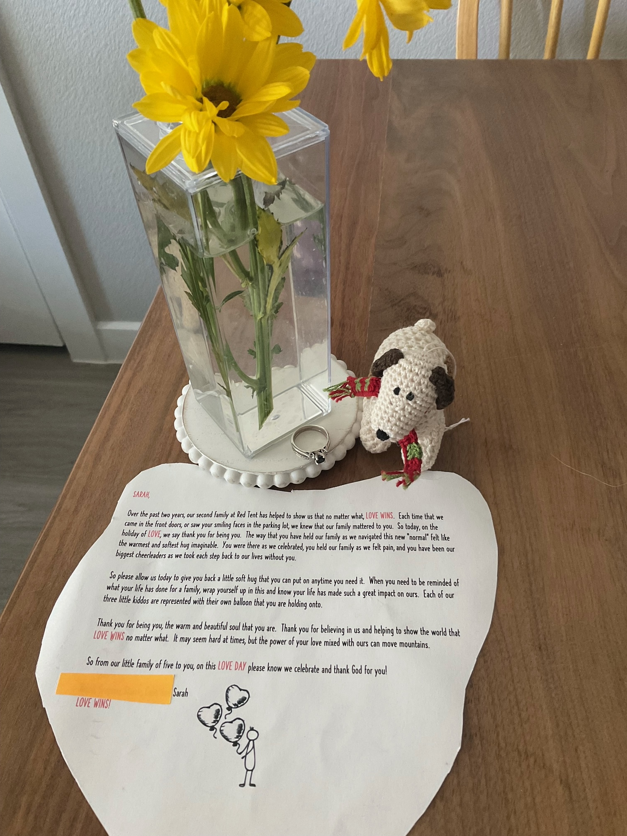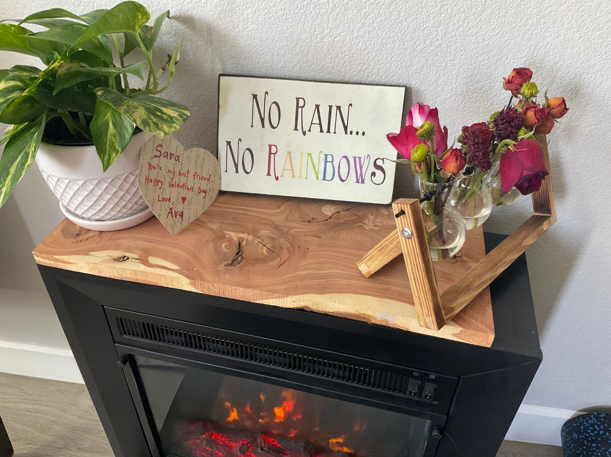

Never again do I want to say: excuse me I need to take some time off to ski so I can process the multiple suicides and first degree murder of a supervision co-parent on the same year of my late term abortion. I will be the mountain that needs to be climbed to prove the parents have their shit together before getting undocumented access to their offspring. OR I will be the red tape and walk the red line as they choose their own destiny as parents.
Ill hold their stories and dignity as my own.
It takes a village-(however…) I’ll burn your whole village down and risk my reputation as a professional while doing it ****if it means there is benefits to the safety and security in my hometown of Parker and the state of Colorado**** sort your life out parents
Your call: be a good parent/person and authentic + enact cooperative co-parenting practices in your household consistently- post divorce/separation for the best interest of the children. —or you’ll be court ordered to have a parent coach like me be your side seat driver to this shitshow you call “family”
Every Family has a Story…I wont judge yours- I’ll influence the ending.

Nice to meet you. Thank you for joining my soapbox rant.
Ask away-the worst thing I’ll say is: “No”.

